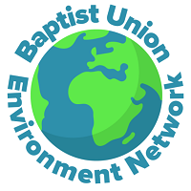
BUEN EBA/CBA meeting
Thursday 30 November
7:30-8:30pm

Minutes

Attendees
Andrew Openshaw, Hannah Gray, Dave Gregory, Tim Mullin, Michelle Eversden-Thomas, Ray Nicholson, Jackie and David Tricker, Andrew Marfleet, David Mayne, Neil Coulsen, Ines Yabar, Jane from Frinton Free, Joe Egan, Steve Gaze.
Welcome – Andrew Openshaw
Update on BUEN news – Dave Gregory
BUEN is now 3 years old. Developing BUEN network hubs across the Baptist associations. There is variety in how these hubs are progressing.
We are seeing the issue of climate change and environmental crisis being raised up by the Baptist Union. National teams have provided support to raise the profile of this issue. We are working with Faith and Society team to provide more guidance on buildings.
Eco Church scheme with A Rocha - 260 Baptist churches have registered for EcoChurch and it is increasing all the time. 35% have awards (up from 25% last year).
The ‘God saw that it was good’ installation of artwork and reflections has been on tour round different churches and events. Dave has developed some films to go with these in association with The Fuelcast, and these should be ready for release in 2024.
Regarding COP28, JPIT is releasing a prayer point each day which will be shared on the BUEN social channels (we have a Facebook and Twitter/X account).
Andrew - BMS have sent an email today about climate and impact on women. How much is BUEN engaging with BMS?
Dave – we have released a blog on BU webpage today in coordination with BMS https://www.baptist.org.uk/Articles/675805/COP28_unity_action.aspx and the prayer video we will show at the end is a joint effort. BUEN is well connected with Laura Lee Lovering, who is their Creation Care Coordinator.

Prayer for COP28
Input from Ines Yabar who will be attending COP28: Ines’ grandparents were from Frinton on Sea, but she was born and lives in Peru. Ines works with UN Foundation and has attended three COP conferences as a youth ambassador. She used to work for Restless Development and her role at previous COPs to bring voices for the young voices which are not represented. This year she is going with the Peru government to help in their pavilion and doing advocacy on education in the climate space. Prayer points from Ines:
- Loss and damage fund to support those who are suffering most from climate change
- For countries who aren’t well represented at COPs
- Prayer against COP being subverted to make oil deals
Prayer jamboard and open prayer: Hannah introduced the prayer jamboard, and we worked together to add post it notes with prayer points on:
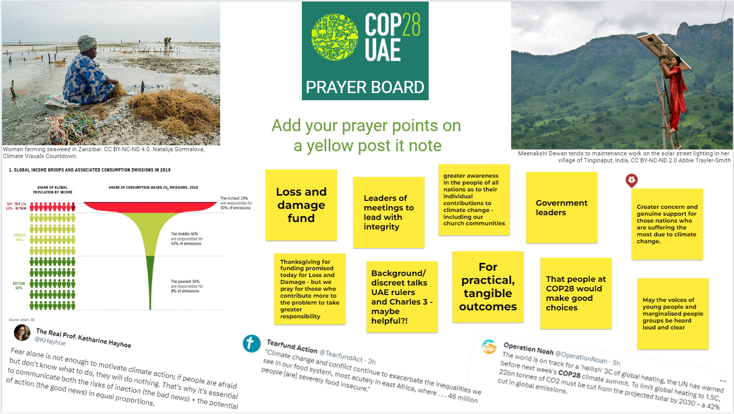

BUEN Prayer Video
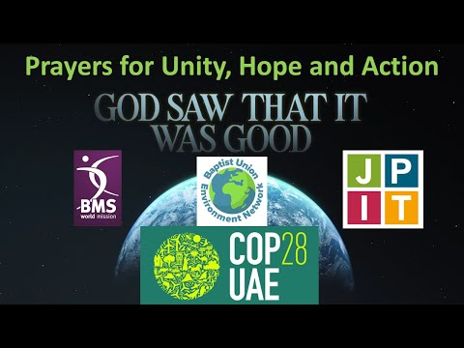

Final remarks
Next meeting date to be confirmed, likely in the first quarter of 2024. Please get in touch with Hannah or Andrew if you have ideas for topics to discuss, would like to lead a session or share something shorter, or have any ideas for speakers to invite along.
You may be interested in the following online event:
John Ray Initiative (JRI) 25th Anniversary Celebration with Katherine Hayhoe, February 6, 2024 @ 7:45 pm – 9:15 pm
https://jri.org.uk/book_events/jri-25th-anniversary-celebration-with-katherine-hayhoe/

Meeting close
Andrew thanked everyone for coming and we finished with the grace.

